**1. Create a Virtual Network in West US:**

* **In Azure Portal**:
  1. Go to "Virtual networks."
  2. Click on "Create."
  3. Select the **West US** region.
  4. Define a name, address space (20.0.0.0/16), and subnets.
  5. Review and create the virtual network.

**2. Create Another Virtual Network in South India:**

* **In Azure Portal**:
  1. Repeat the above steps for **South India**.
  2. Name the virtual network and provide an address space (10.1.0.0/16).
  3. Add subnets and deploy.

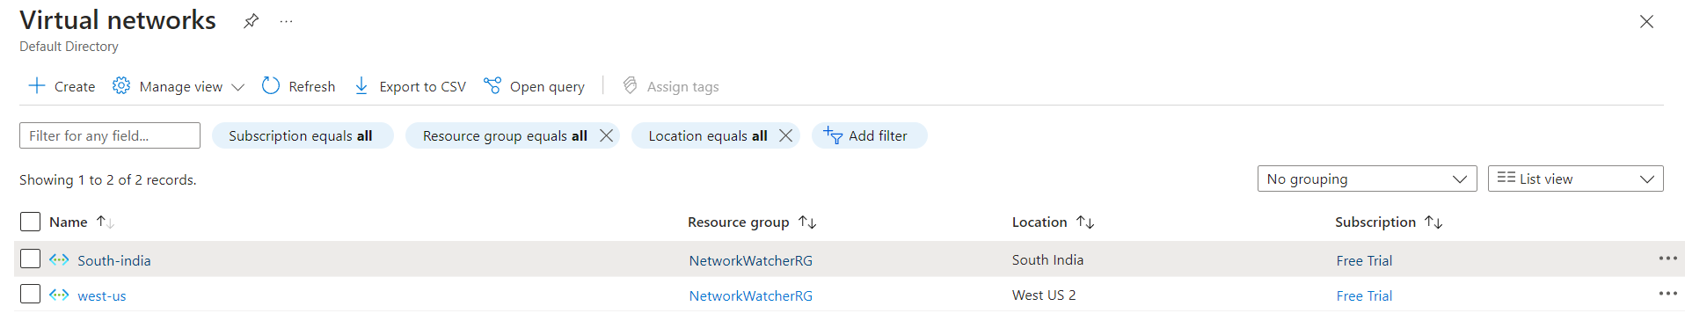

**3. Deploy a Virtual Machine in West US:**

* **In Azure Portal**:
  1. Go to "Virtual Machines."
  2. Click "Create."
  3. Select **West US** for the region.
  4. Assign the VM to the **West US Virtual Network** created earlier.
  5. Choose an OS image (windows), size, authentication, and storage.
  6. Complete the setup and launch the VM.

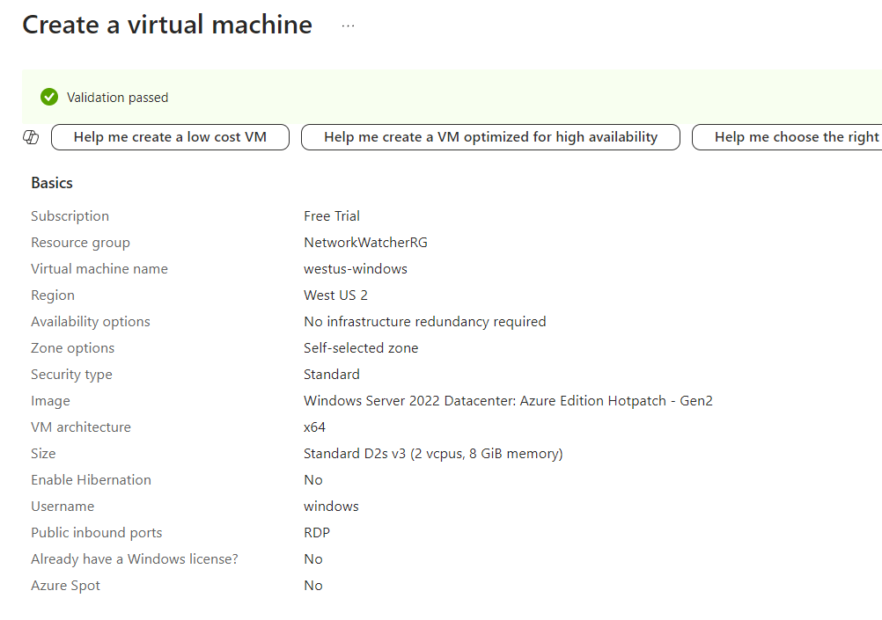

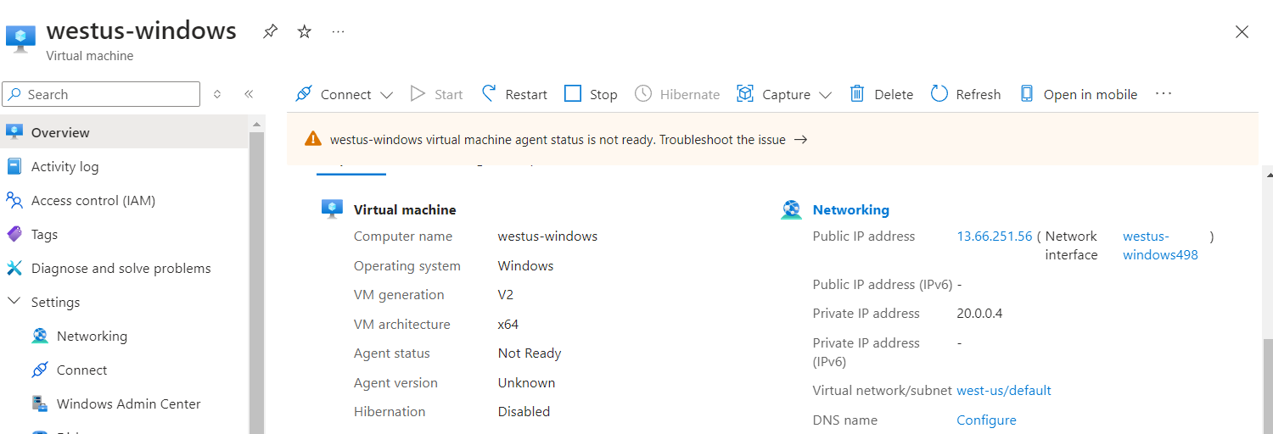

**4. Deploy a Virtual Machine in South India:**

* **In Azure Portal**:
  1. Repeat the steps to create another virtual machine in **South India**.
  2. Make sure the VM is connected to the **South India Virtual Network**.
  3. Complete deployment.

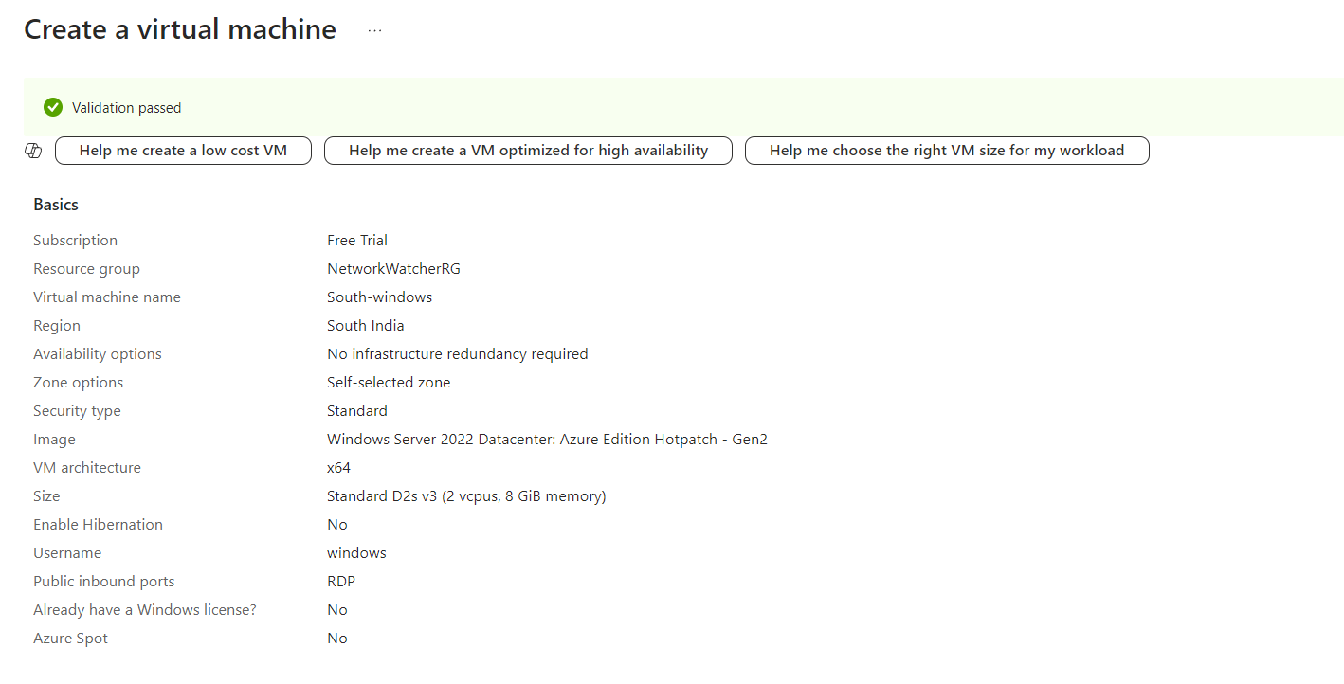

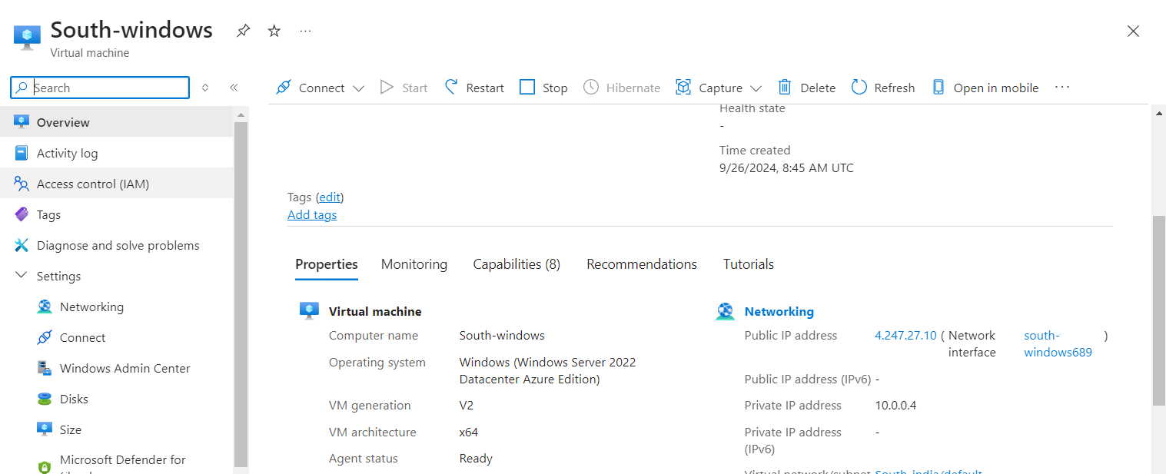

**5. Assign a Static IP Address to the VM:**

* **In Azure Portal**:
  1. Once the VM is deployed, navigate to the **Virtual Machine** you just created.
  2. Under the "Settings" section, click on **Networking**.
  3. Under the "Network Interface" section, click on the **network interface** associated with the VM.
  4. In the network interface settings, click on **IP configurations**.
  5. Select the **IP configuration** (usually named ipconfig1).
  6. Under **Assignment**, change the **IP address assignment** from **Dynamic** to **Static**.
  7. Click "Save."

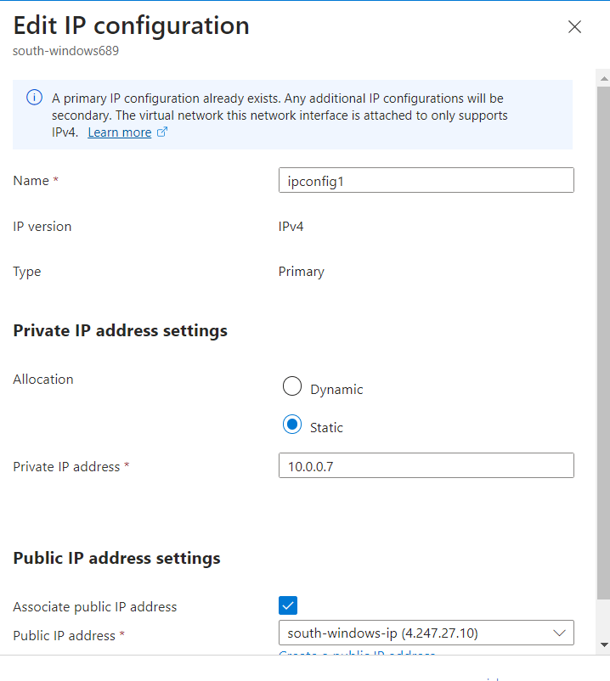

**6. Create a New Network Interface (NIC)**

* **In Azure Portal**:
  1. Go to **Networking**.
  2. Under "Settings" on the left side, select **Network interfaces**.
  3. Click **Add** to create a new NIC.
  4. Specify the following details:
     + **Name**: Provide a name for the new NIC.
     + **Virtual network**: Select the virtual network where you want the NIC to reside (the same one used for your VM).
     + **Subnet**: Choose the subnet associated with the virtual network.
     + **Private IP**: Set it to either **Dynamic** or **Static** depending on your requirements.
  5. Click **Review + Create** and then **Create** to deploy the NIC.

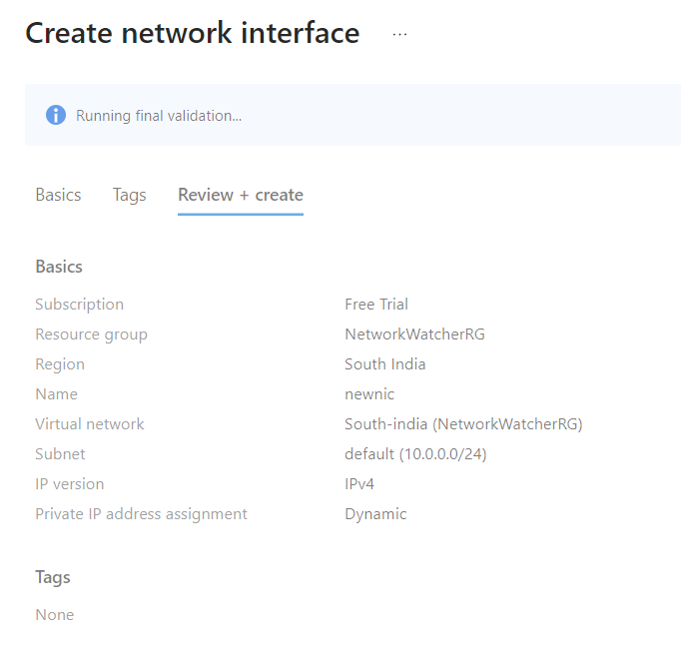

**7. Attach NIC to the Previously Created VM**

* **In Azure Portal**:
  1. Once the NIC is created, navigate back to your previously created VM.
  2. Under "Settings," click on **Networking**.
  3. In the **Network interface** section, click on **Attach network interface**.
  4. Select the newly created NIC from the list and click **OK**.

